# CS 340 README

## About the Project

**Project Title**:

**Interactive Jupyter Dash Dashboard Using MongoDB Animal Collection, from the AAC Dataset**

## *This project was created to address the needs of Grazioso Salvare by working with the Austin Animal Shelter database. It leverages the module.py module, which establishes a connection to the database and enables Create, Read, Update, and Delete (CRUD) operations. The project uses Plotly's Dash framework, allowing users to interact with and visualize data using Data Tables. It also utilizes Plotly Express for generating graphs and Leaflet for displaying maps. Pandas plays a crucial role in managing and manipulating the project's data.*

## *Motivation*

## *The primary motivation behind this project is to provide Grazioso Salvare with a streamlined solution for efficiently filtering through the vast amount of data in the Austin Animal Shelter database. The dashboard offers quick access to information about available dogs for different types of rescue training. Additionally, it provides graphical representations of the outcome type for dogs that meet the rescue type criteria. It also includes animals and their geographical locations on a map.*

## *Getting Started*

## *To run this project locally, you need to have access to the MongoDB server with valid credentials. Ensure that you have Python and Jupyter Notebook installed on your system. Download the module.py module and the Project2FinalCs340.ipynb script. You might need to adjust the directory paths for aac_crud.py and the logo used in the dashboard application to match your setup.*

## *Installation*

## *MongoDB Access: Obtain access to the MongoDB server with valid credentials.*

## *Python and Jupyter Notebook: Ensure Python and Jupyter Notebook are installed on your system.*

## *Download Files: Download the module.py module and the Project2FinalCs340.ipynb script.*

## *Directory Configuration: Adjust directory paths for module.py and the logo within the dashboard application as needed.*

## *Usage*

## *Functionality*

## *Running the program will display a header, company-logo, a Data-Table containing the rows from the AAC database, using the animal’s collection, and an interactive bubble-plot visualization, and geolocation map with hover label and tag. You can interact with the program by clicking on various filter buttons, which dynamically re-query the database with specific attributes, selecting items from the legend, typing in the filter boxes, and hovering over data points. The map and graph components will also update accordingly based on your chosen filters.*

## *Screencast:*

## *For a visual demonstration of the application's functionality, refer to the included screencast below. The screencast starts by introducing the program and the dashboard's features. It showcases the functionality of the filter buttons, providing a clear understanding of how to use the application effectively.*

[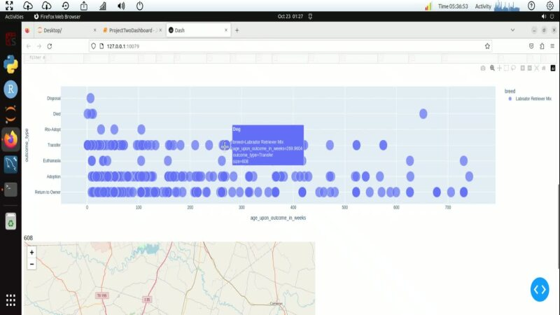](https://snhu-my.sharepoint.com/:v:/r/personal/ws_tammy_hartline_snhu_edu/Documents/Desktop/cs340TammyDashboard.webm?csf=1&web=1&e=E0jF1D)

## *Bugs:*

## *The only found bug that I was unable to correct, is when the rescue filters (radio buttons) are selected, the data does populate in the bubble plot, but it removes the data from the table.*

## *Contact*

## *For any inquiries or assistance, please reach out to:*

## *Developer: SNHU Senior- Tammy Hartline*

## *Email:* [*tammyhartline@gmail.com*](mailto:tammyhartline@gmail.com) *or* [*tammy.hartline@snhu.edu*](mailto:tammy.hartline@snhu.edu)